**Programming the Physical World**

**Getting Input from a Pushbutton**

In this lab we are going to write a program that interfaces with computer hardware to make something physical occur, specifically blink Morse code on a Light Emitting Diode (LED).

For this activity we will require the following:

1. Raspberry Pi
2. Four male/female jumper wires
3. Solderless breadboard
4. Pushbutton switch
5. HDMI to DVI cable

The hardware we will be using will be the Raspberry Pi which has 18 GPIO (General Purpose Input Output) pins which can be easily programmed to send output signals to or receive input signals.

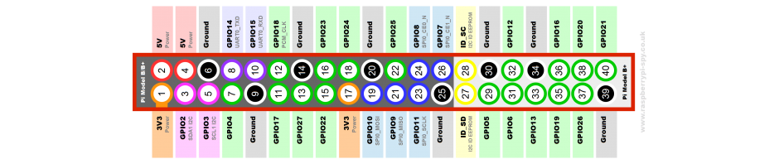

For this activity, we will be using pins 6 and 11. These correspond to Ground and GPIO 17 respectively.

Start IDLE as follows:

1. Open the Run Dialog (Start|Run)
2. Type sudo idle
3. Hit Enter

Enter program 1 and see what happens.

#Program 1

import RPi.GPIO as GPIO

buttonPin = 17

GPIO.setmode(GPIO.BCM)

GPIO.setup(buttonPin, GPIO.IN)

input = GPIO.input(buttonPin)

while True:

if (GPIO.input(buttonPin)):

print "Button pressed"

This did not work too well because of a phenomenon known as switch bounce. We will try to improve this using by slowing down our loop.

#Program 2

import RPi.GPIO as GPIO

import time

buttonPin = 17

GPIO.setmode(GPIO.BCM)

GPIO.setup(buttonPin, GPIO.IN)

prev_input = 0

while True:

input = GPIO.input(buttonPin)

if ((not prev_input) and input):

print "Button pressed"

prev_input = input

time.sleep(0.05)

Finally we will make a final improvement

#Program 3

import RPi.GPIO as GPIO

import time

buttonPin = 17

GPIO.setmode(GPIO.BCM)

GPIO.setup(buttonPin, GPIO.IN, pull_up_down = GPIO.PUD_UP)

while True:

input_state = GPIO.input(buttonPin)

if input_state == False:

print "Button pressed"

time.sleep(0.2)